 User Guide
ETAS Integration for (F/X)ETK v1.1 beta
How to integrate the ETK driver and A2L adaption for all ETK features DRAFT

Copyright
The data in this document may not be altered or amended without special notification from ETAS GmbH. ETAS GmbH undertakes no further obligation in relation to this document. The software described in it can only be used if the customer is in possession of a general license agreement or single license. Using and copying is only allowed in concurrence with the specifications stipulated in the contract.
Under no circumstances may any part of this document be copied, reproduced, transmitted, stored in a retrieval system or translated into another language without the express written permission of ETAS GmbH.
© Copyright 2025 ETAS GmbH, Stuttgart
The names and designations used in this document are trademarks or brands belonging to the respective owners.
ETAS Integration for (F/X)ETK’s | User Guide R01 EN – 09.2025 DRAFT
Contents
1 Introduction 5
1.1 Definitions and Abbreviations 5
1.2 Conventions 6
2 General usage of (F/X)ETK’s with different uC types 7
3 ETK driver structure 8
4 Handshake 9
4.1 Needed Files 9
4.2 Changes in Files for integration 10
4.2.1 CompileTime.c 10
4.2.2 ETK_Integration_Cfg.h 10
4.2.3 ETK_SER_Handshake.h 11
4.2.4 GetTime.h / Base.h 11
4.3 Call of function 11
4.4 A2L configuration in XCT Tool 12
5 Measurement methods 13
5.1 Distab17 method 13
5.1.1 Needed Files 13
5.1.2 Changes in Files for integration 14
5.1.3 Call of function 15
5.1.4 A2L configuration in XCT Tool 16
5.1.5 Verify in XCT Tool and use in INCA 18
5.2 Trace based measurement method 19
5.2.1 Needed Files 19
5.2.2 Changes in Files for integration 19
5.2.3 Call of function 20
5.2.4 A2L configuration in XCT Tool 21
5.2.5 Verify in XCT Tool and use in INCA 21
5.3 Supplementary Distab measurement method (Actual not supported) 22
5.3.1 Needed Files 22
5.3.2 Changes in Files for integration 22
5.3.3 Call of function 23
5.3.4 A2L configuration in XCT Tool 24
5.3.5 Verify in XCT Tool and use in INCA 25
6 Calibration 26
6.1 Needed Files 26
6.2 Changes in Files for integration 26
6.2.1 ETK_SER_Page_Ctrl_Fct.c/.h 26
6.2.2 ETK_Integration_Cfg.h 27
6.2.3 Call of function 27
6.2.4 A2L configuration in XCT Tool 28
6.2.5 Verify in XCT Tool and use in INCA 31
7 Advanced Code Check (ACC) 35
7.1 Needed Files 35
7.2 Changes in Files for integration 35
7.2.1 ETK_CodeCheck.c 35
7.2.2 ETK_Integration_Cfg.h 36
7.2.3 Call of function 36
7.2.4 A2L configuration in XCT Tool 37
7.2.5 Verify in XCT Tool and use in INCA 37
8 Coldstart measurement 39
8.1 Changes in Files for integration 39
8.1.1 ETK_SER_Coldstart.c 39
8.1.2 ETK_Integration_Cfg.h 40
8.1.3 Call of function 40
8.1.4 A2L configuration in XCT Tool 40
8.1.5 Verify in XCT Tool and use in INCA 40
9 Contact Information 43
Figures 44
Tables 45
Index 46
Revision History 47

Introduction

Definitions and Abbreviations
AML
ASAM-MCD 2MC (aka ASAP2) Meta Language
A2L
ASAM-MCD 2MC (aka ASAP2) Description Language
DISTAB
Display Table is the method used for Data Acquisition
ECU
Electronic Control Unit
EMEM
Extension Memory
ERAM
Emulation Random Access Memory
ETK Tool
Configuration Toolset used to configure the ETK, FETK and XETK devices
HWC
Hardware configuration from workspace in INCA
PD-device
Production device without trace unit and EMEM
RP
Reference Page
UML
Unified Modelling Language by OMG (Object-Modelling-Group). Graphical Modelling Language for SW Engineering/Development
WP
Working Page
XCP
Extended Calibration Protocol ASAM-MCD 1 (XCP)
XCPoE
Extended Calibration Protocol over Ethernet
XCT
XETK Configuration Tool used to configure the (some ETKs), FETK and XETK devices

Conventions
The following typographical conventions can be used in this document:
OCI_CANTxMessage msg0 = | Code snippets are presented on a gray background and in the Courier font.  Meaning and usage of each command are explained by means of comments. The comments are enclosed by the usual syntax for comments. Changes are red marked.
Choose File Open. | Menu commands are shown in boldface.
Click OK. | Buttons are shown in boldface.
Press <Enter>. | Keyboard commands are shown in angled brackets.
The "Open File" dialog box is displayed. | Names of program windows, dialog boxes, fields, etc. are shown in quotation marks.
Select the file setup.exe | Text in drop-down lists on the screen, program code, as well as path- and file names are shown in the Courier font.
A distribution is always a one-dimensional table of sample points. | General emphasis and new terms are set in italics.

General usage of (F/X)ETK’s with different uC types
The ETK family comprises ETKs, XETKs and FETKs modules. Each of these modules offers a different set of functionality and performance.
In this document are all steps described how to integrate the ETK driver and how each function or feature works.
Following functions are mandatory for measurement and calibration :
- Handshake (like a login of ETK)
- Measurement (Distab17 and Trace )
- Calibration (Page Switch Mechanism with two page concept)
Additional features are :
- ACC (Advanced Code Check)
- Coldstart Measurement (Able to measure and calibrate before ignition on)
- CalWup (Calibration Wakeup – power supply of ECU)

In this version document is used a basis ETK driver version tag_20260624_A_BRS3C_TC4xx_ExampleCode_V1_2_6_HS_D17_CAL_ACC_CS_TRACE / tag_20260624_A_TC4xx_ExampleCode_V1_2_5_adapted_code .

NOTE:
In this document will be explained how to integrate the ETK driver in ECU software. When you need support or explanation of the function you can order an integration workshop or engineering hours.

NOTE:
It is assumed that the user is familiar with the use and handling of XCT Tool, HSP and INCA.

NOTE:
The define for used compiler is in the related header file Target_Select_TC4xx.h .

ETK driver structure
The ETK driver has the normal uC OS with basic functions in the folder source.
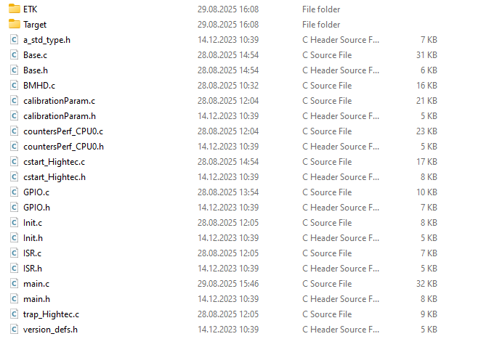
In the subfolder Target for each uC type, like TC4XDx, is the information which target is selected in the file here Target_Select_TC49x_N.h. This defines the uC type, class and which compiler is used and will be copied with renaming in handshake folder from batch file.
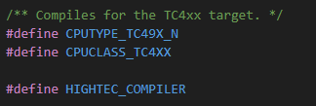
The subfolder ETK contains all necessary functions and features in an own. It’s recommended to copy all folders to your desired directory of your build and only compile what’s needed.
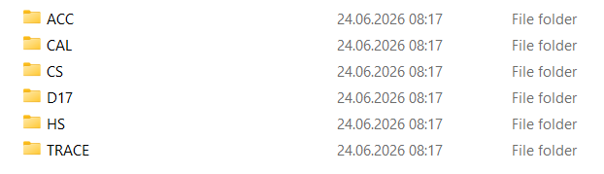
As additional hint for linking of some sections which are not used or unreferenced. In this case its helps to use for example with Tasking #pragma protect on ….. #pragma restore.
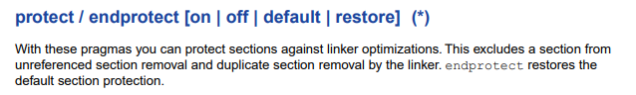

Handshake
After the microcontroller is running at the final PLL speed, all reset Pins are high (/PORST and /ESR0) and also VDD is high, then ETK can start with the handshake procedure, which allows write and read access RAM and read access to FLASH. It’s like a login for uC.

Needed Files
At first copy the folder ETK into your folder with folder HS containing following files :
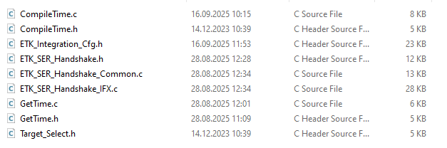
Here a short description of the files :
CompileTime.c/.h is later for the advanced code check but is needed also for the handshake. Here its mandatory that the const for CODE_CHECK_PATTERN_DATA_DATE will be created.
ETK_Integration_Cfg.h contains all defines for activation of features and functions, the register information’s and the calibration definitions.
ETK_SER_Handshake_Common.c is the general handshake sequence.
ETK_SER_Handshake_IFX.c is the specific sequence for IFX controllers.
ETK_SER_Handshake.h is the structure header for handshake.
GetTime.c/.h contain the time functions for calculation of timeouts, duration of handshake and initialization of RAM.
Target_Select.h is definition of CPU type and CPU class.

Changes in Files for integration
Here is definition what must be adapted to ECU software for integration and what must be linked in linker file.

CompileTime.c
#include "../../a_std_type.h" should be change to the file for standard types. Typically is used the name Platform_Types.h.
For later if ACC (advanced code check) will be used, which is recommended, then the ".ETK_Code_checkMemClass" must assigned to an address in linker which is located in the reference page (DATA FLASH).
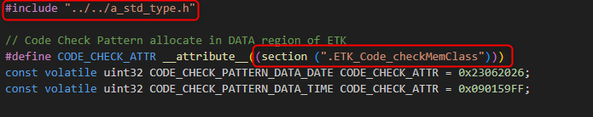
group CAL_PARAM : ALIGN(4)
{
*(.rodata.CAL_PARAM)
*(.CAL_PARAM)
*(.rodata.*.CAL_PARAM)
*(.measure_parameters)
*(.ETK_Code_checkMemClass)
*(.coldstart_parameters);
} > CAL_DATA

ETK_Integration_Cfg.h
Most important file for integration which is needed in each step. Here can be changed which function or feature is activated through integration.
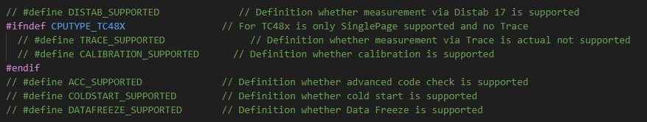
#include "../../a_std_type.h" should be change to the file for standard types. Typically is used the name Platform_Types.h. Same as before in CompileTime.c.
Here now will be also linked the register file where all addresses of registers are linked. You can use the delivered .sfr file from ETAS TC49x_N_MCSFR.sfr which works for related TC49x_N uC or use the include from your own .sfr file. The define for which sfr file is in the Target_select.h.
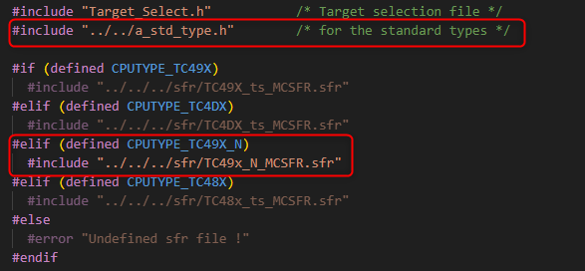

ETK_SER_Handshake.h
#include "../../a_std_type.h" should be change to the file for standard types. Typically is used the name Platform_Types.h.

GetTime.h / Base.h
In the example driver for V1_2_6_HS_D17_CAL_ACC_CS_TRACE are the functions for time calculation in the GetTime.c file. For the V1_2_5_adapted_code is used the Base.h. But when the customer code is used its only recommended to use the GetTime.c/h files.
#include "../../a_std_type.h" should be change to the file for standard types. Typically, is used the name Platform_Types.h.
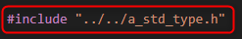
When V1_2_5_adapted_code is used for customer code following setting is needed.
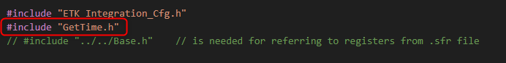

Call of function
There are two types of handshakes. The initial handshake with all functionalities and the cyclic handshake, if the initial handshake was successful, but ES master or PC not connected.
The initial handshake must be called before the OS is running and after setting up the PLL. This will be called via command SER_Initial_Handshake_Execute();.
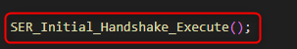
The cyclic handshake must be called in a runnable / raster with the recommended time cycle of 10ms and is called SER_Cyclic_Handshake_Check_And_Execute();.
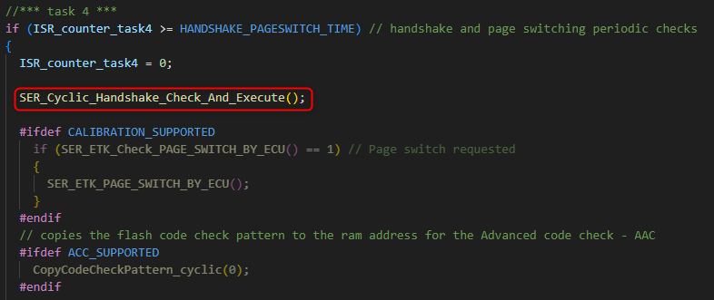
For both handshake types the same header files are needed. Please add:
#include "ETK/HS/ETK_Integration_Cfg.h"
#include "ETK/HS/ETK_SER_Handshake.h"

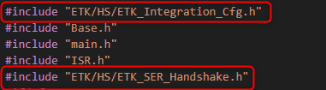

A2L configuration in XCT Tool
When the code is compiled and flashed, the ETK must be configured so that handshake will be made by ETK.
Best is to use a blank default configuration from XCT tool (4.4.4 Build 120r) where you choose the uC and ETK type. Then set Handshake Timeout [ms] to -1 (infinity). When this is set, ETK tries to make a handshake as long as the handshake is successfully performed. This means he is accessing to the IOSR and COMDATA register in this time.
For example, I will use the BR_XETK-S3C and TC49x_N device, because this supports all functions and features like TraceToRam.
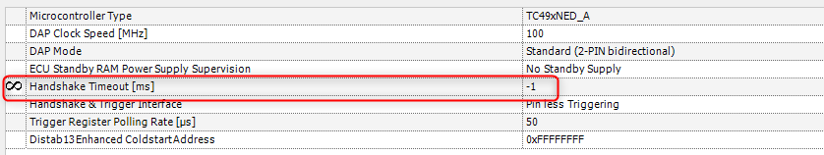
When this configuration is downloaded then you can see after reset or power on the ECU the handshake is performed, and you have access to RAM and flash in hex editor.
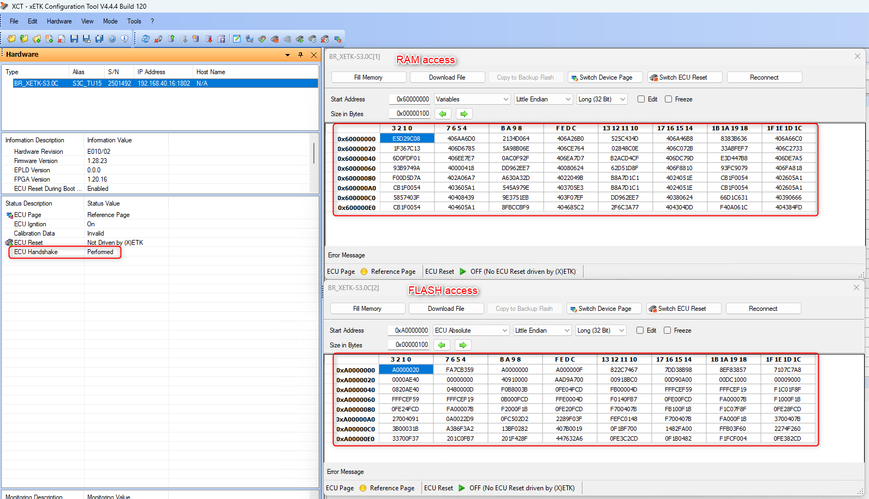

Measurement methods
After the handshake is done there are two different types for measurement, Distab17 and Trace. Both can work standalone and be combined to Trace with supplementary Distab.

Distab17 method
Distab means Display Table and is a measurement method which gets an address list from INCA Experiment over Event Config Area (located in RAM and be written from ETK) and copies in a runnable the values into the Config Output Area (located in RAM and written by ECU), where the ETK takes the data and provide it back to INCA or third party tool.

Needed Files
At first copy the folder D17 into your folder structure in the folder ETK with following files:
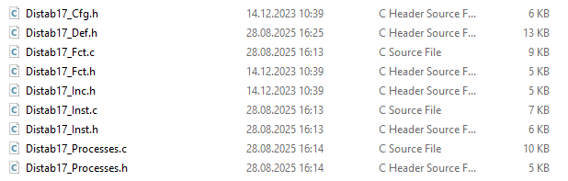
Here a short description of the files :
Distab17_Cfg.h is the configuration file where the maximum events and size of config and output area are defined. Also defines supplementary Distab.
Distab17_Def.h contains the base type definitions for all Distab based ECU routines.
Distab17_Fct.c/.h containing the function implementation to process a Distab event.
Distab17_Inc.h contains the type definitions for Distab data.
Distab17_Inst.c/.h containing the declaration of the Distab17 data structs. Relevant section for linker.
Distab17_Processes.c/.h - This function looks up the event configuration, decides whether this event is enabled, used TDM or the output table, if necessary invokes the data copy and finally executes the trigger.

Changes in Files for integration
Here is definition what must be adapted to ECU software for integration and what must be linked in linker file.

ETK_Integration_Cfg.h
Activate the Distab17 measurement method by activating define DISTAB_SUPPORTED.
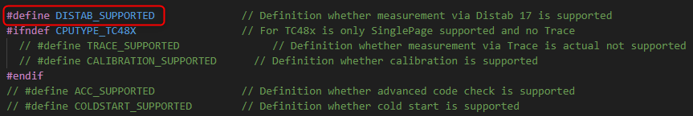

Distab17_Cfg.h
Here in general only two changes should be done. These are the sizes for the config area and output area size where the addresses and output values are located. This can be calculated manually by the formula:
4 Bytes header/event list + 4 Bytes/event + 24 Bytes header/raster + 4 bytes address/signal + signal size
When you have an available A2L file you also can select in INCA in VSD all measurements and then you get visualized how many bytes are selected. This you can use as estimated value for config and same for output area.
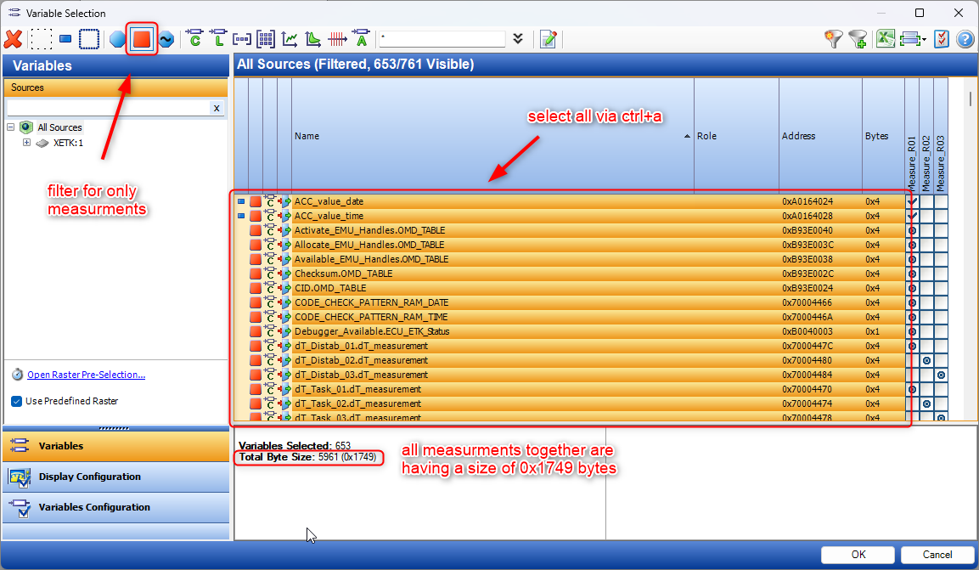
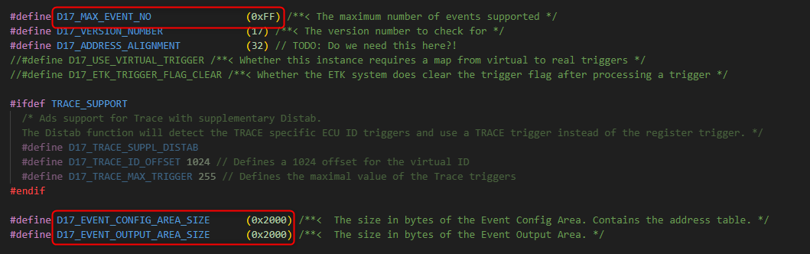
The default value for maximum number of Distab events is 255. With this number the eventlist has a size of 0x400 bytes. With reducing this number, the size of eventlist will also decrease. I recommend to change that to 0x20, because XETK can measure only 32 rasters and only 32 register triggers are available.

Distab17_Inst.c
All data structures needed for the ECU part of using the Distab17 are instantiated here. Important for Distab17 is the alignment of 4 Byte for all three different sections for the linker.
"ETK_DisTab17_EventList"
"ETK_DisTab17_EventConfigArea"
"ETK_DisTab17_EventOutputArea"
You can link them where you want. As recommendation it should be linked to any RAM which is soft reset resistant and will not lose the data to measure over an reset. It can be linked to any location of SRAM or LMU/DLMU. Best is to create a group for Distab in linker file. In this example its located on Dspr0 from Core0 (0x70000000). I advise also to set a fix value for this linker section that when some future changes will be done the addresses are not changing. So you can avoid to change the parameters in A2L file every new software build.
.bss (NOLOAD) : ALIGN(4)
{
select "*.ETK_DisTab17_EventList";
select "*.ETK_DisTab17_EventConfigArea";
select "*.ETK_DisTab17_EventOutputArea";
} > dspr0

Call of function
The Distab process will be called in each runnable the customer wants to get a Distab raster for measurement in INCA or in third party tool.
The Distab process must be called in a runnable / raster with a defined time cycle or synchronous time cycle and is called with an index beginning with 1 like Distab17_Process(1);. Best is to use the fastest raster with the lowest index number.
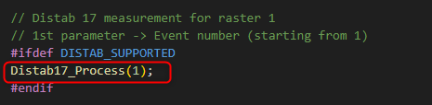
For example, you have three runnable’s with 1ms, 10ms and 100ms you set the calls like following:
FUNC(void, Xetk_CODE) Xetk_CyclicEvent1ms()
{
Distab17_Process(1);
}…
FUNC(void, Xetk_CODE) Xetk_CyclicEvent10ms()
{
Distab17_Process(2);
}…
FUNC(void, Xetk_CODE) Xetk_CyclicEvent100ms()
{
Distab17_Process(3);
}
You must add following header file which is needed in your runnable file. Please add:
#include "ETK/D17/Distab17_Processes.h"
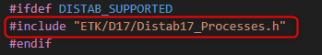

A2L configuration in XCT Tool
When now the code is compiled and flashed the ETK must be configured that Distab eventlist, config and output area is known for ETK. Also, the memory segment must be defined and the Distab runnable/raster created with definition of cycle time.
Now load the before created A2L file in XCT tool, open in parallel the .map file and search for the addresses for the Distab eventlist, config and output area.
First important part is that they must be in a memory segment from type VARIABLES RAM, because ETK must know where he can write and read.

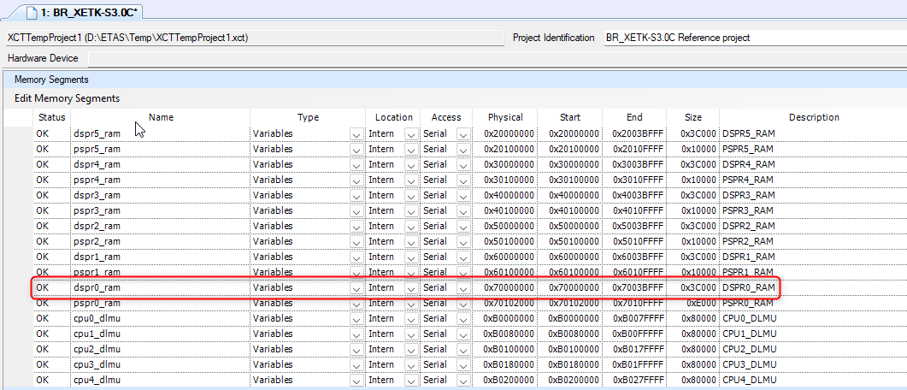
Now go to the tab Distab Editor, activate Distab Version 17 and enter the addresses from map file for eventlist, config and output area start with each size. Then add the number of triggers depending on number of runnable/raster and assign the ECU ID (index number). I recommend using ECU ID = Trigger number = index of Distab process. Then it’s easier later for understanding and usage. At least add the data acquisition channel range for the used Distab raster. Here you can use in this case 1 to 3 but I recommend using 1 to 32 because when later more runnable/raster ´s are added then it’s easier to change.
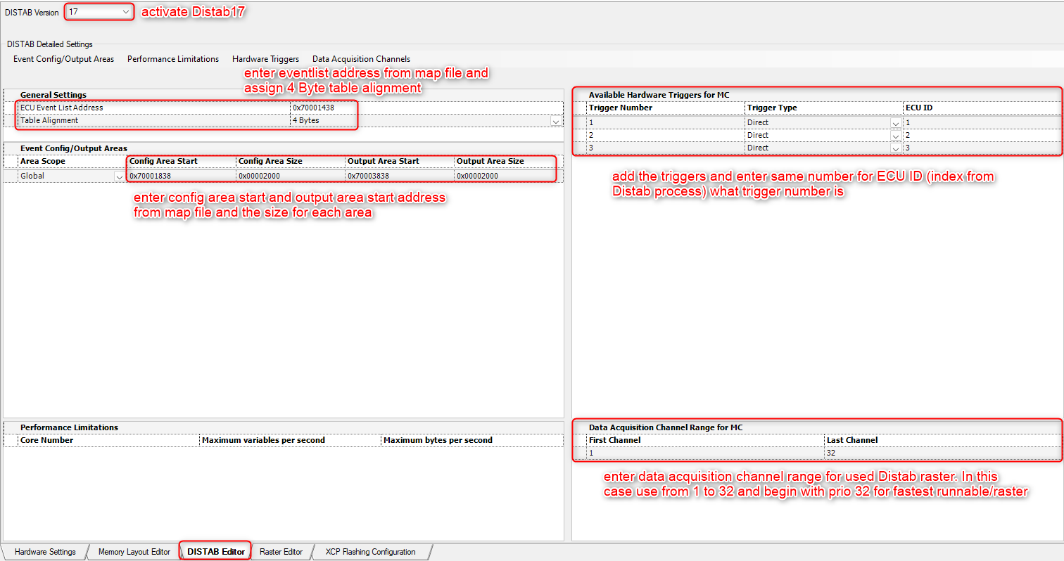
Now go to the tab Raster Editor and add you runnable/raster ‘s with name, t in microseconds for cycle time, highest priority for fastest raster, Distab for acquisition control and trigger source you can choose a fixed Hardware Trigger or a Dynamic. I recommend Dynamic Trigger, then ETK detects which Trigger is correct one.
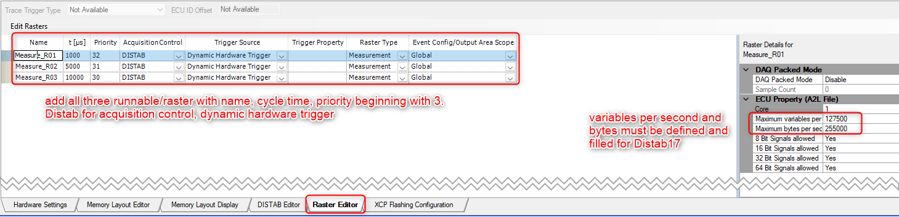
Then generate A2L file, merge A2L snippet with measurements. Now measurement in INCA should work. The ECU property for variables per second and bytes per second must not be zero for Distab17. If its zero, then TDM is used instead of Distab17 !!!

Verify in XCT Tool and use in INCA
After import A2L in INCA, initialize and reconfigure your ETK then you can add variables to the defined raster.
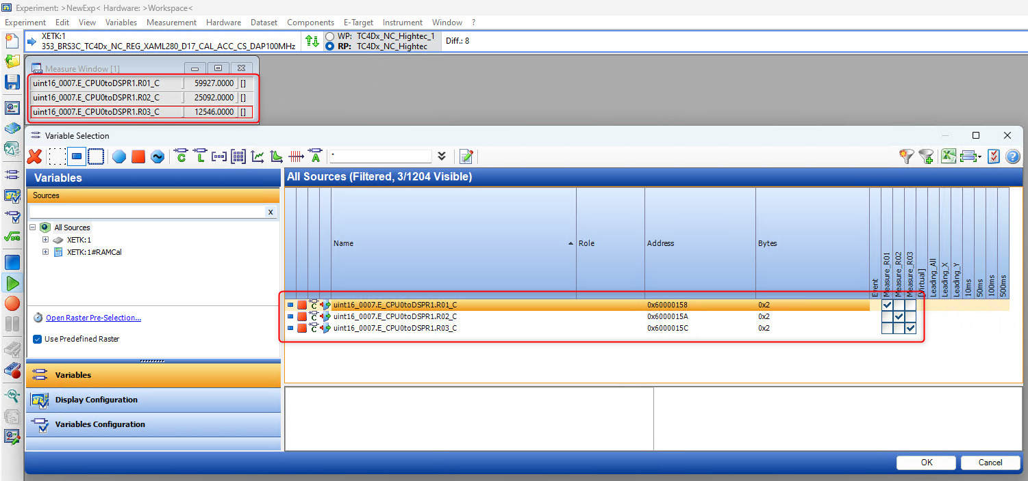

To verify that you can connect in parallel with XCT tool and open with hex editor the eventlist, config and output area and see the configuration and the values changing. In this example I have added for each runnable/raster one 2-byte signal from Core1 (0x6000….).
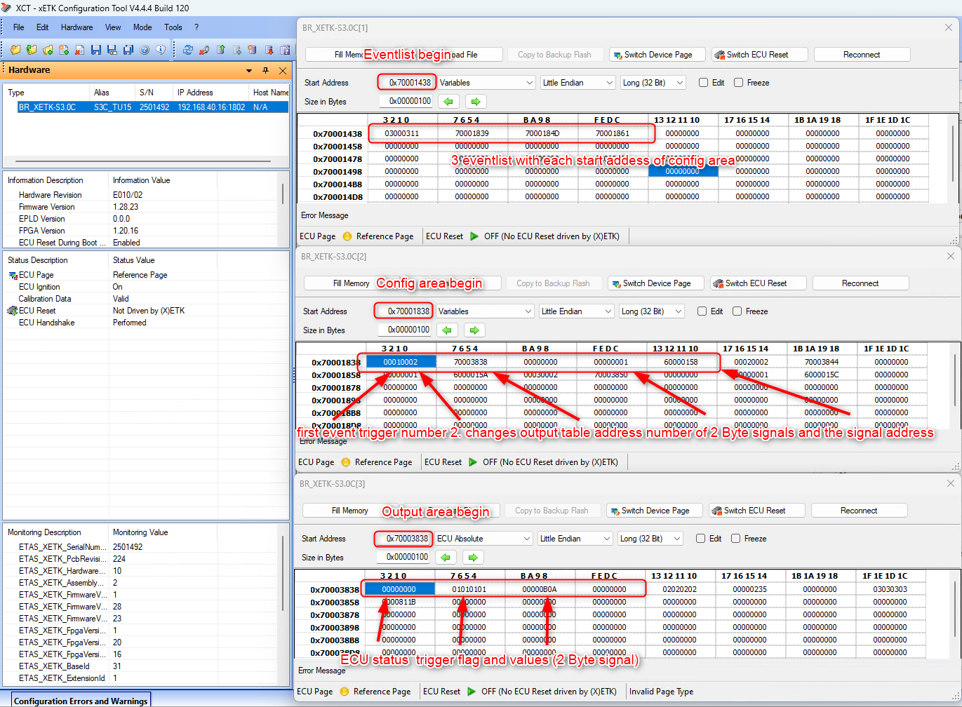

Trace based measurement method
Trace data is stored in the special memory when TraceToRam is only possible. By default, this memory consists of a regular memory array (TCM – Trace Calibration Memory) built out of RAM Blocks (Tiles), which can be split into a Trace memory and a Calibration memory part. When TraceToPin (FETK-T) is used then the whole memory can be used as Calibration Memory. When TraceToRam is used the first 512 Kbyte will be used as Trace Fifo.
For Trace is no event config and or output area necessary. This will be done by the Trace engine and unit inside memory. Only trace windows must be defined for ETK where the ETK takes the data and provide it back to INCA or third-party tool.

Needed Files
At first copy the folder TRACE into your folder structure in the folder ETK:
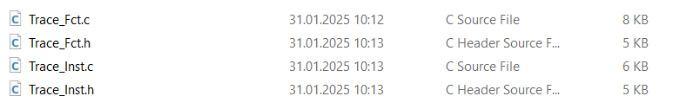
Here a short description of the files :
Trace_Fct.c/.h contains the function to write the trace trigger.
Trace_Inst.c/.h containing the declaration of the trace data structs. Relevant section for linker.

Changes in Files for integration
Here is definition what must be adapted to ECU software for integration and what must be linked in linker file.

ETK_Integration_Cfg.h
Activate the trace measurement method by activating define TRACE_SUPPORTED.
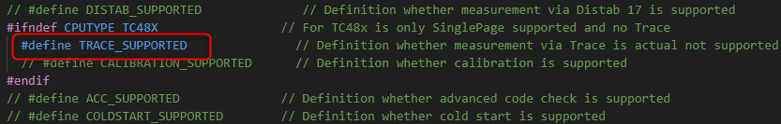

Trace_Fct.c
Here must two changes be done. #include "../../a_std_type.h" should be change to the file for standard types. Typically, is used the name Platform_Types.h.
And comment the line for Distab17_Fct,h, because this is only needed when supplementary Distab is used.
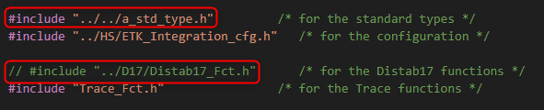

Trace_Inst.c
#include "../../a_std_type.h" should be change to the file for standard types. Typically, is used the name Platform_Types.h.
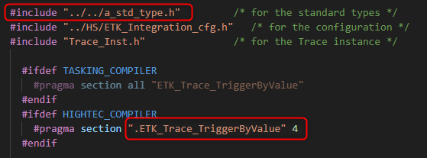
"ETK_Trace_TriggerByValue"
You can link it where you want, and it should be 4 byte aligned. As recommendation for uC with EMEM it should be linked to the EMEM and the other can be linked to any location of SRAM or LMU/DLMU. I advise also to set a fix value for this linker section that when some future changes will be done the addresses are not changing. So, you can avoid changing the parameters in A2L file every new software build.
.bss (NOLOAD) : ALIGN(4)
{
select "*.ETK_Trace_TriggerByValue";
} > dspr0

Call of function
The trace trigger will be called in each runnable the customer wants to get a Trace raster for measurement in INCA or in third party tool.
The trace trigger must be called in a runnable / raster with a defined time cycle or synchronous time cycle and is called with the trigger number beginning with 1 like TraceExecTriggerByValue(1);. Best is to use the fastest raster with the lowest trigger number.
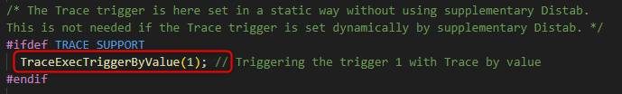
For example, you have three runnable’s with 1ms, 10ms and 100ms you set the calls like following:
FUNC(void, Xetk_CODE) Xetk_CyclicEvent1ms()
{
TraceExecTriggerByValue (1);
}…
FUNC(void, Xetk_CODE) Xetk_CyclicEvent10ms()
{
TraceExecTriggerByValue (2);
}…
FUNC(void, Xetk_CODE) Xetk_CyclicEvent100ms()
{
TraceExecTriggerByValue (3);
}
You must add following header file which is needed in your runnable file. Please add:
#include "ETK/ TRACE/Trace_Fct.h"
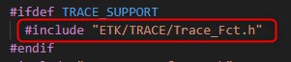

A2L configuration in XCT Tool
When now the code is compiled and flashed the ETK must be configured for trace windows and where is the trace trigger.
Now load the before created A2L file in XCT tool with handshake, open in parallel the .map file and search for the address from trace trigger.
Now go to the tab Memory Layout Editor and add the trace windows with start address and size where your measurements are located. Then assign bus master/slave and enable if needed/wanted FGT (fine grain trace).
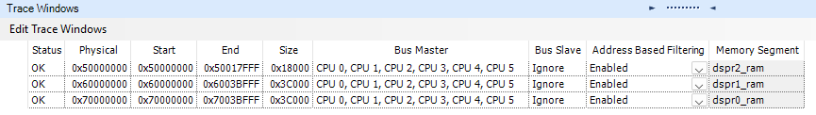
Now switch the tab to Raster editor and add for each trace trigger in a runnable/raster a new trace raster with cycle time, priority (for all same), Trace for acquisition control and new Trace for trigger source. Then change trigger address and value of runnable/raster.
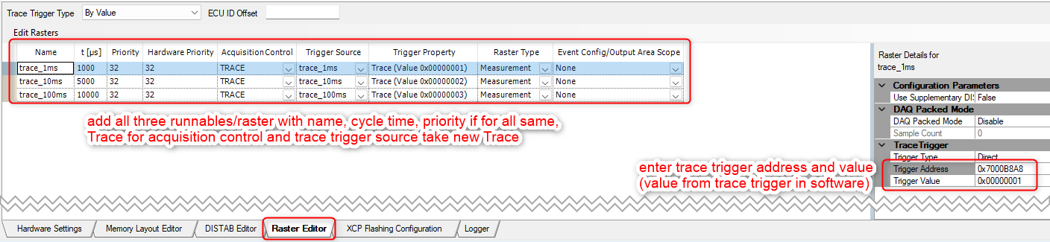
Then generate A2L file, merge A2L snippet with measurements. Now measurement in INCA should work.

Verify in XCT Tool and use in INCA
After import A2L in INCA, initialize and reconfigure your ETK then you can add variables to the defined raster. To check that all is working as expected you can open in parallel XCT tool and look over monitoring variable ETAS_XETK_TraceCurrent the actual trace data rate and see in hex editor on trace trigger address when trace trigger is written from ECU software. In this example trace trigger is located at 0x7000B8A8.

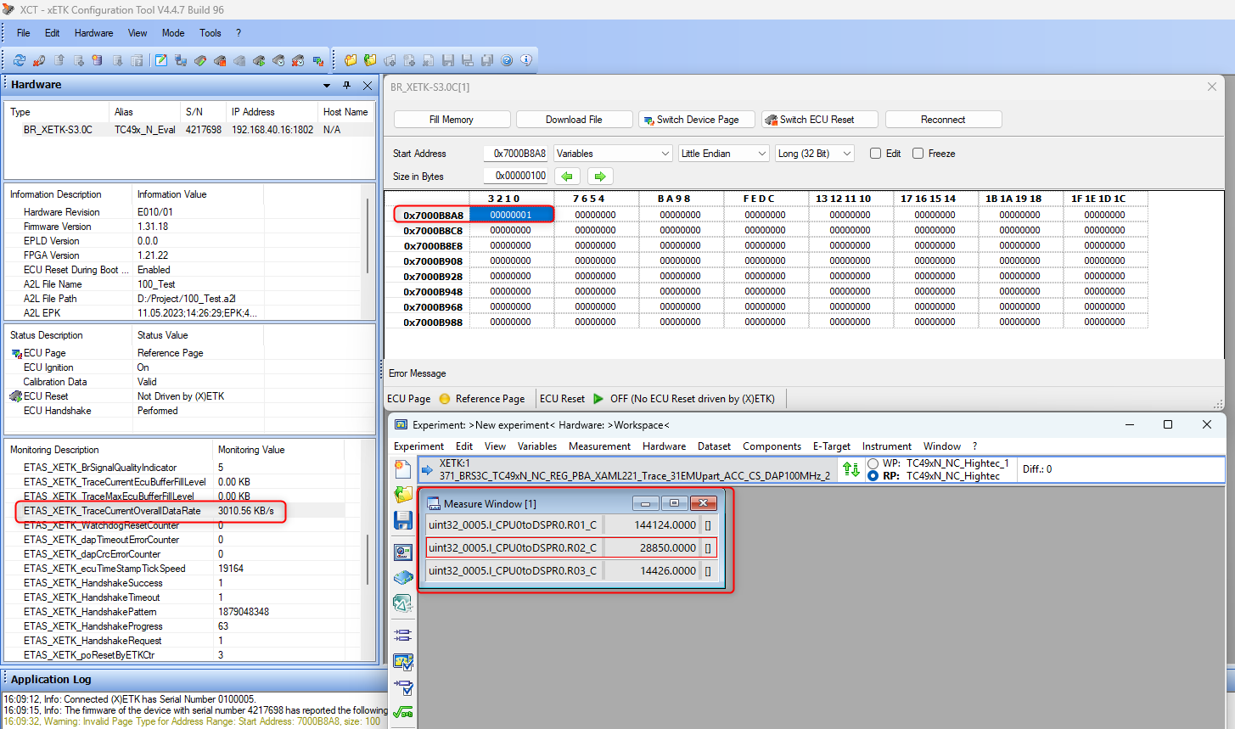

Supplementary Distab measurement method (Actual not supported)
This is a combination of trace based measurement with Distab and is needed when not all measurement variables can be measured via trace due to missing trace windows and this will be measured then via Distab, which is then located inside of a trace window. In this case only trace runnable/raster are defined.

Needed Files
For this you need to copy both folder TRACE and DISTAB into your folder structure :
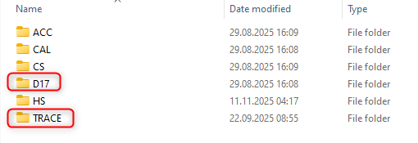
The description of the files you can find under 5.1.1 and 5.2.1.

Changes in Files for integration
Here is definition what must be adapted to ECU software for integration and what must be linked in linker file.

ETK_Integration_Cfg.h
Activate the Distab and Trace measurement method by activating define DISTAB_SUPPORTED and TRACE_SUPPORTED.
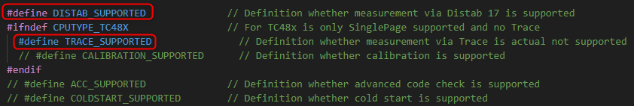

Here you must do all the changes from Trace and Distab. Only difference here is that in the file Trace_Fct.c the #include "../D17/Distab17_Fct.h" must be active.
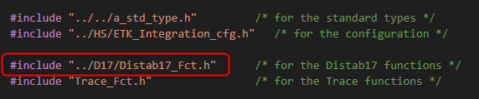

Call of function
The supplementary Distab will be called over Distab process in each runnable the customer wants to get a Trace raster for measurement in INCA or in third party tool.
The Distab process must be called in a runnable / raster with a defined time cycle or synchronous time cycle and is called with an index beginning with 1 like Distab17_Process(1);. Best is to use the fastest raster with the lowest index number.
For example, you have three runnable’s with 1ms, 10ms and 100ms you set the calls like following:
FUNC(void, Xetk_CODE) Xetk_CyclicEvent1ms()
{
Distab17_Process(1);
}…
FUNC(void, Xetk_CODE) Xetk_CyclicEvent10ms()
{
Distab17_Process(2);
}…
FUNC(void, Xetk_CODE) Xetk_CyclicEvent100ms()
{
Distab17_Process(3);
}

You must add following header file which is needed in your runnable file. Please add:
#include "ETK/D17/Distab17_Processes.h"

A2L configuration in XCT Tool
When now the code is compiled and flashed the ETK must be configured that Distab eventlist, config and output are is known for ETK. Also, the memory segment must be defined and the Distab runnable/raster must be created as Trace with definition of cycle time, configured as supplementary Distab and set the trace trigger for supplementary Distab.
Now load the before created A2L file in XCT tool where only handshake is configured, open in parallel the .map file and search for the addresses for the Distab eventlist, config and output area.
First important part is that they must be in a memory segment from type VARIABLES RAM, because ETK must know where he can write and read.
Now go to the tab Distab Editor, activate Distab Version 17 and enter the addresses from map file for eventlist, config and output area start with each size. Then add the number of triggers depending on number of runnable/raster and assign the ECU ID (index number). I recommend using ECU ID = Trigger number = index of Distab process. Then it’s easier later for understanding and usage. At least add the data acquisition channel range for the used Distab raster. Here you can use in this case 1 to 3 but I recommend using 1 to 32 because when later more runnable/raster ´s are added then it’s easier to change.
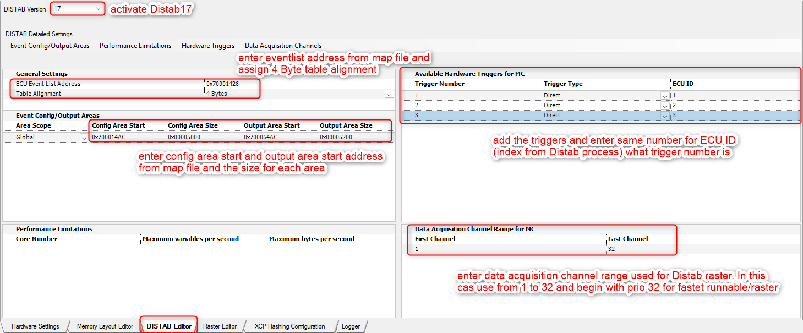
After that go to the tab Raster Editor and add your runnable/raster ‘s with name, t in microseconds for cycle time, priority (for all same), Trace for acquisition control and new Trace for trigger source. Then change trigger address for supplementary trace trigger and value of runnable/raster.
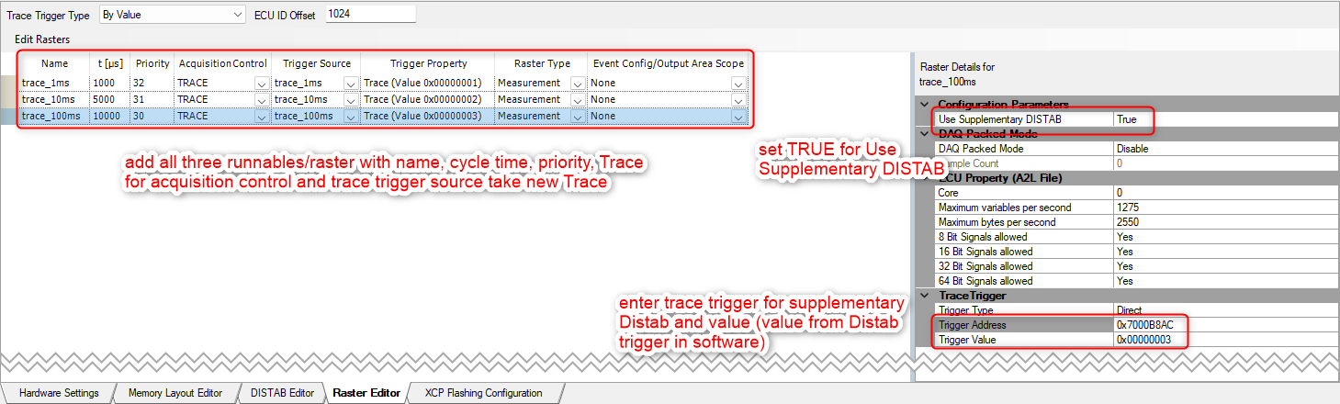
After generating A2L file please verify that in section for trace trigger the ECU_ID entry with 1024 is there. This is needed due to default Distab17 settings. If it’s missing please add it.
/begin TRACE_TRIGGER_CFG
TRACE_TRIGGER 0 0x70000024
CONFIG "MaxTriggerValue" "3"
ECU_ID 1024
/end TRACE_TRIGGER_CFG

Verify in XCT Tool and use in INCA
After import A2L in INCA, initialize and reconfigure your ETK then you can add variables to the defined raster. To check that all is working as expected you can open in parallel XCT tool and look over monitoring variable ETAS_XETK_TraceCurrent the actual trace data rate and see in hex editor on trace trigger address for supplementary Distab when trace trigger is written from ECU software. In this example trace trigger is located at 0x7000B8AC.
Then also you can have a look when variables are not located in a trace window if its measure via Distab. For this open hex editor and look on address where Distab config area and output area is.
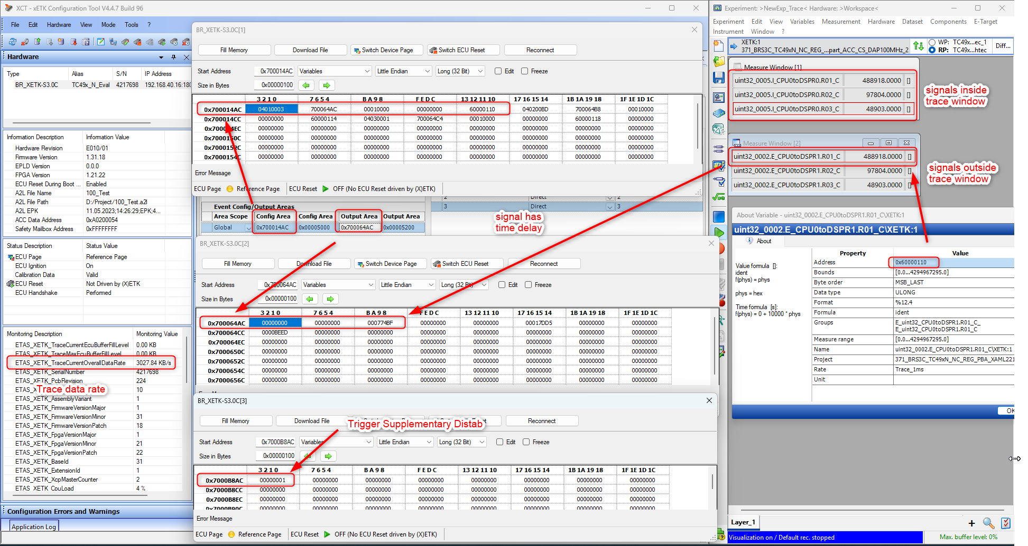

Calibration
The calibration with ETK works after the two page concept. The reference page is related to the FLASH and the working page is located in any SRAM/EMEM/LMU and is a copy of reference page where parameter/curves/maps can be changed/calibrated. When TC48x is selected then automatically will be calibration deactivated.

Needed Files
At first copy the folder CALIB into the folder structure in the folder ETK with following files:
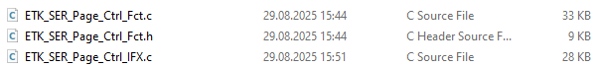
Here a short description of the files :
ETK_SER_Page_Ctrl_Fct.c/.h contains the structure and check of OMD, page switch mechanism, the activation of calibration and dis- and enbling of interrupts.
ETK_SER_Page_Ctrl_IFX.c is configuration of registers for calibration and EMEM tiles, if needed for ED-devices. This also contains the data cache invalidate function.

Changes in Files for integration
Here is definition what must be adapted to ECU software for integration and what must be linked in linker file. In this case is in the added files nothing to change. Only in the

ETK_SER_Page_Ctrl_Fct.c/.h
Nothing mut be changed in the file..
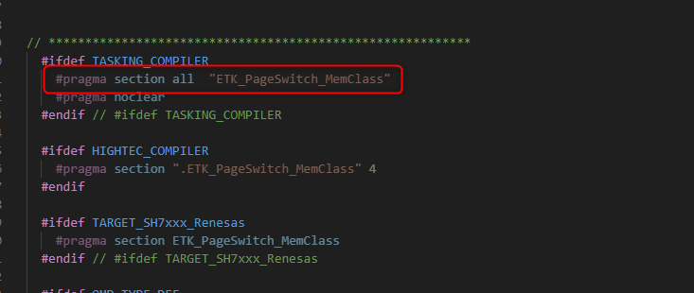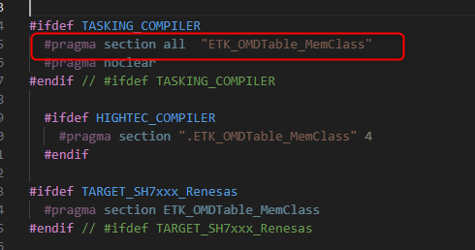
Here you need two parts for calibration. The page switch mailbox and the OMD table.
"ETK_PageSwitch_MemClass"
"ETK_OMDTable_MemClass"
You can link it where you want, and it should be 4 byte aligned. As recommendation for uC with EMEM, where you want to store working page over ECU sleep or reset, it should be linked to the EMEM and the other (PD-devices) can be linked to any location of SRAM or LMU/DLMU. I advise also to set a fix value for this linker section that when some future changes will be done the addresses are not changing. So, you can avoid changing the parameters in A2L file every new software build.
group EmuRAM_CodeCheck_Pattern(ordered, run_addr=0xB93E0000)
{
select "*.code_checkMemClassEMURam";
select "*.ETK_PageSwitch_MemClass";
select "*.ETK_OMDTable_MemClass";
}

ETK_Integration_Cfg.h
Activate the calibration method by activating define CALIBRATION_SUPPORTED. This can be activated independent from measurement.
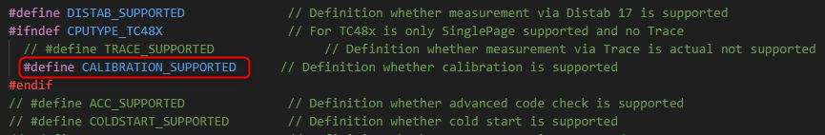

Call of function
The calibration process will be called in one runnable.
The page switch must be called only in one runnable / raster with a defined time cycle. and is called with SER_ETK_PAGE_SWITCH_BY_ECU();. Best is to use a 10ms runnable / raster for that.
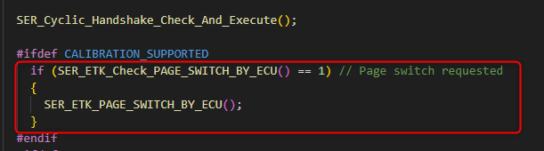
When the cached flash is used and you calibrate values on working page then this value will not be updated inside of the cache and this will have no influence on functions who are working with that. In this case the data cache must be invalidated, when no such function is available in the software. When this happens please call at the end of the task (depends on how often this must be called,, I recommend 10ms) the data cache invalidate function via calling dataCacheInvalidate();.
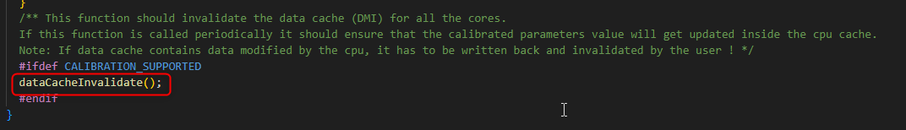
For example, you have three runnable’s with 1ms, 10ms and 100ms you set the call in 10ms following:
FUNC(void, Xetk_CODE) Xetk_CyclicEvent1ms()
{
Distab17_Process(1);
}…
FUNC(void, Xetk_CODE) Xetk_CyclicEvent10ms()
{
Distab17_Process(2);
if (SER_ETK_Check_PAGE_SWITCH_BY_ECU() == 1) // Page switch requested
{
SER_ETK_PAGE_SWITCH_BY_ECU();
}
dataCacheInvalidate();
}…
FUNC(void, Xetk_CODE) Xetk_CyclicEvent100ms()
{
Distab17_Process(3);
}
You must add following header file which is needed in your runnable file. Please add:
#include " ETK/CALIB/ETK_SER_Page_Ctrl_Fct.h"
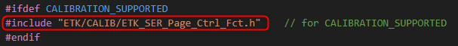

A2L configuration in XCT Tool
When now the code is compiled and flashed, the ETK must be configured that page switch mailbox and OMD table are known for ETK. Also, the memory segment must be defined which contains the page switch mailbox and OMD table.
Now load the before created A2L file in XCT tool, open in parallel the .map file and search for the addresses for the page switch mailbox and OMD table.
First important part is now to enter on layer Hardware Settings the mailbox address and OMD address with there settings.
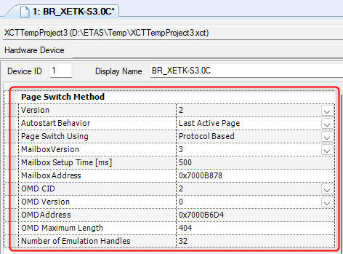
The Version is 2, Autostart Behaviour is per default Last Active Page and Protocol Based page switch is used. MailboxVersion can only be 3 and for Mailbox Setup Time enter a value between 100ms and 500ms. When value 0 is used page switch will never work. This must be avoided. For MailboxAddress take the address from map file. Here ist 0x7000B878. In this example code only OMD CID 2 is supported. As OMD version only 0 can be used.
For OMDAddress take the address from map file. Here ist 0x7000B6D4. The maximum length comes from the size of OMDTable_MemClass with 0x1A4 = 420. In general 32 handles are used for calibration. But now I use the last part of EMEM for other things like OMD table, page witch mailbox etc. (Distab can be located there, ACC). So number of emulation handles is 31.
Second important part is on layer Memory Layout Editor that they must be located in a memory segment from type VARIABLES RAM, because ETK must know where he can write and read. In this case with it will be used in DSPR0 with address 0x70000000. The TC4xx has no memory which is hard reset resitent so it can placed anywhere in the ECU.
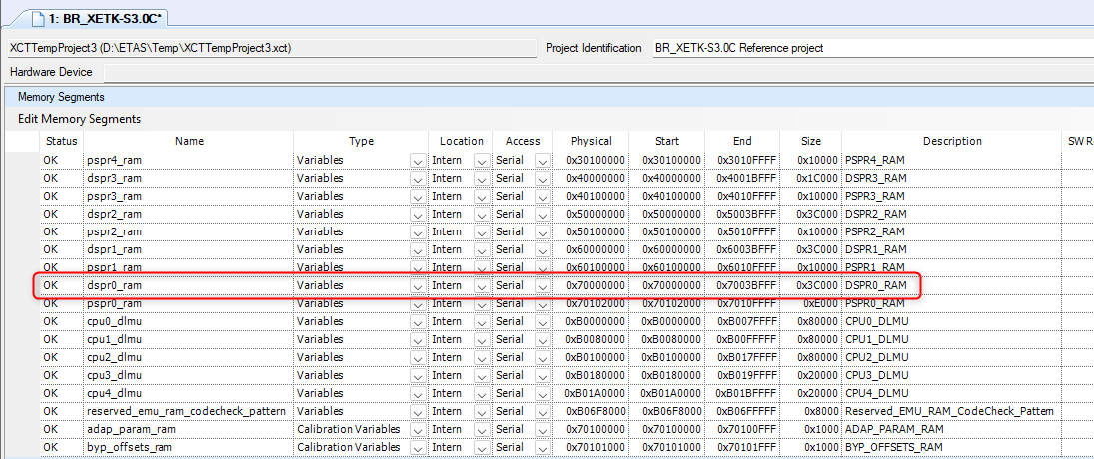
Now also a DATA FLASH segement is needed which defines the reference page. CODE FLASH segments are not mandatory bur can be used for checksum calculation to compare if data in ECU from CODE section is same like in INCA.
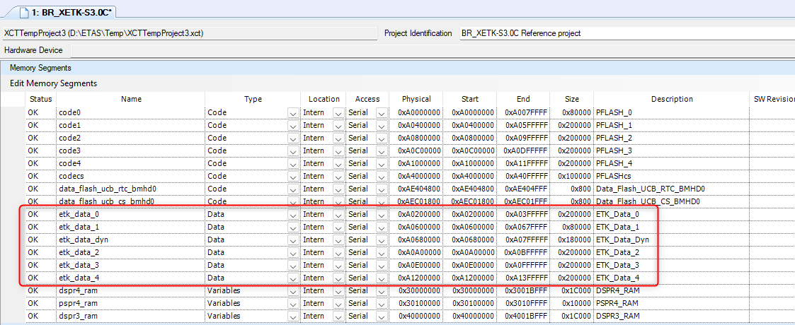
Depending on calibration method for Infineon are three different methods available. More will be told in the integration workshop.

Calibration Method Fixed Size
This method is also needed when later the (F/X)ETK will be used in 3rd party usecase as XCP device. Here the handles can be defined on different locations, but they must all have the same size. Important thing is they are aligned to their size and may only include data areas that are also initialized. In this example is used a part of NVM flash.
At first click on Fixed Size and Create a default handle set. Then change the original address where you want to locate your working page. The size must be the same for all calibration handles. The emulated address will be dynamically filled in INCA depending on which characteristics are added in a experiment.
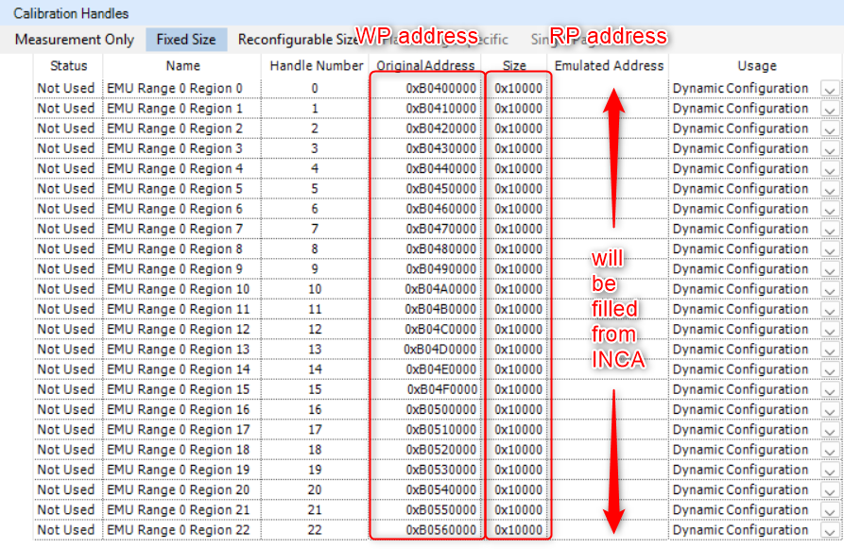

Calibration Method Reconfigurable Size
This method can only be used with INCA. Here the user define one big block for working page with start address and size, where then later depending on size of data flash segments the handles can be defined with variable sizes. In this case the minimum alignment of a data flash segment must be 0x20. With that calibration method you can handle many different data flash segments with different sizes with only one definition and INCA calculates and configures dynamically the calibration handles.
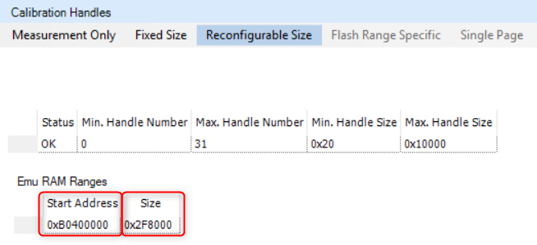

Then generate A2L file, merge A2L snippet with measurements and characteristics. Now calibration in INCA should work.

Calibration Method Single Page
This method can only used with INCA and every ETK. Some uC’s are only supporting SinglePage and then this is needed. Here the user define one big block for working page with start address directly in the memory segment where data flash is located. Other data flash segments for ETK access are not allowed.

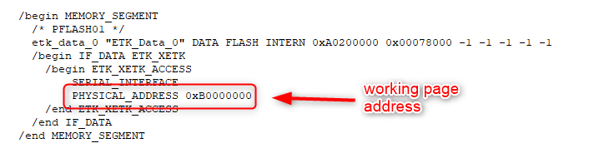
Also in the configuration part from ETK type must be added two lines for single page.

CONFIG "SinglePageOnly" "1"
CONFIG "Page0Writable" "1"

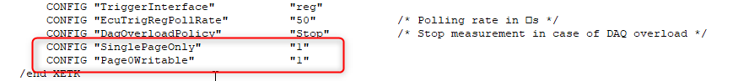

With that configuration no implementation for ETK driver is needed for calibration. With SinglePage you cannot switch the page and you are the whole time on working page.
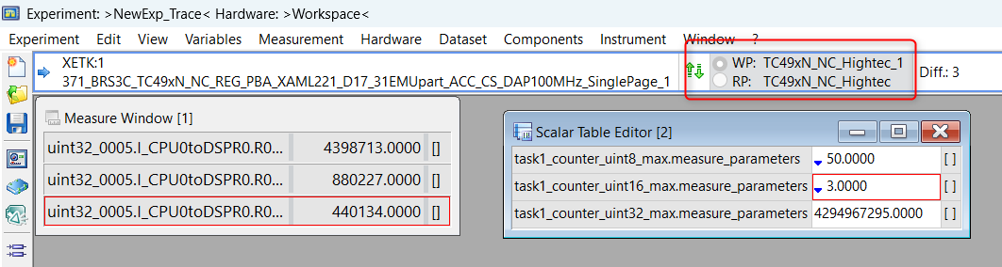

Verify in XCT Tool and use in INCA
After import A2L in INCA, reconfigure and initialize in the hardware configuration you should be able now to see, that checksum calculation will be done depending on your memory segment definition for code, working and reference page. This you can verify in the MPM (memory page manager).
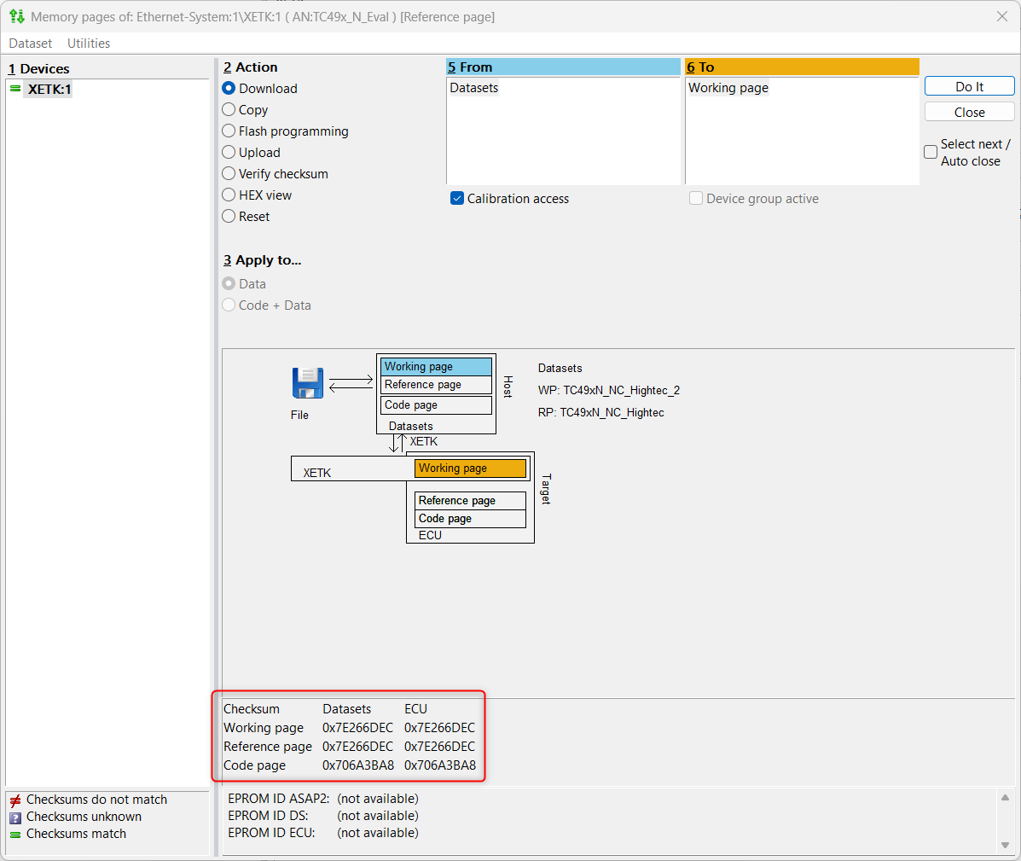

After that the experiment can be opened and characteristics can be added.
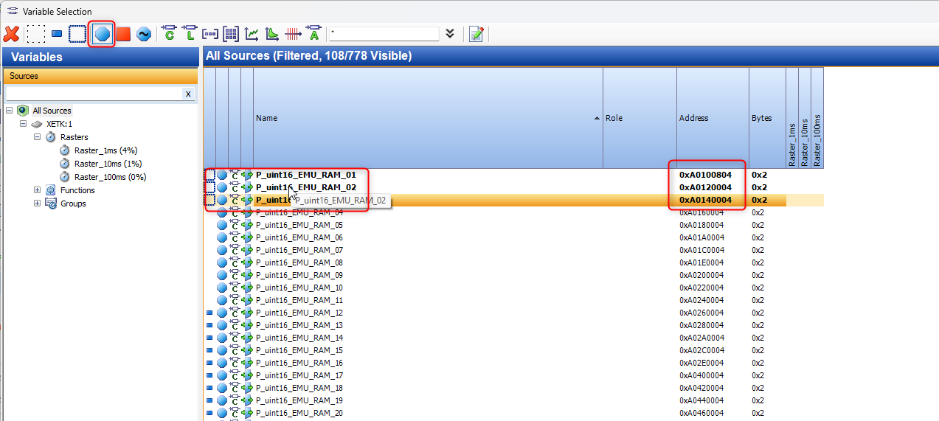
After switching the page in experiment, you are able to change values in the calibration windows. Increase changes are displayed with red arrow and decreased values with blue arrow to the original value. The Diff : 3 shows that overall, 3 Bytes where changed. This can differ from number of changed variables depending on byte size of each characteristic.
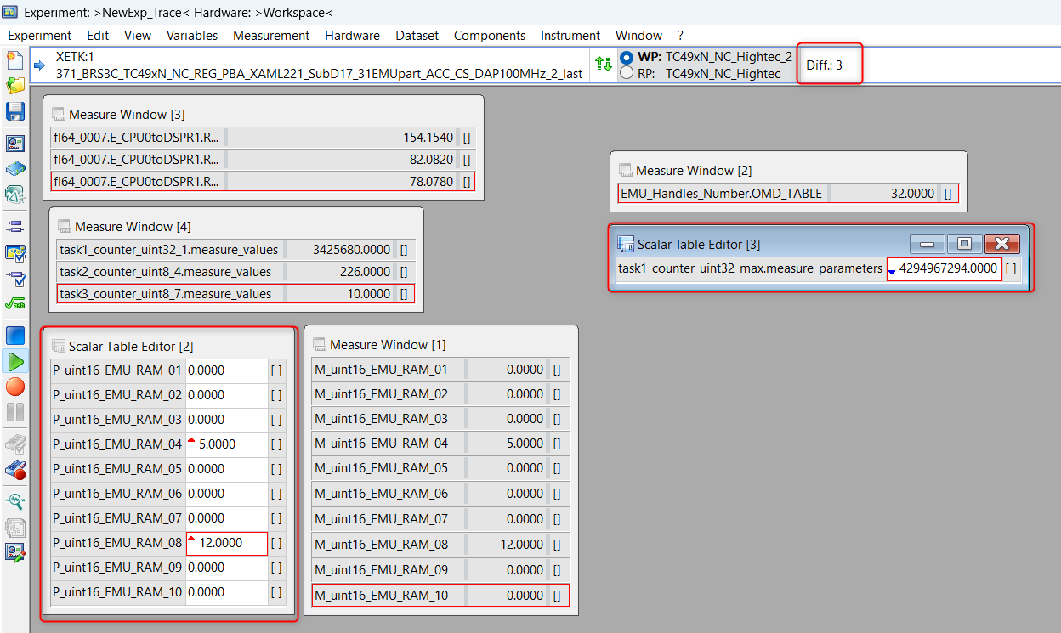
To verify the used and active calibration handles you can open the configuration over Variables Limited Emulation RAM Show Configuration
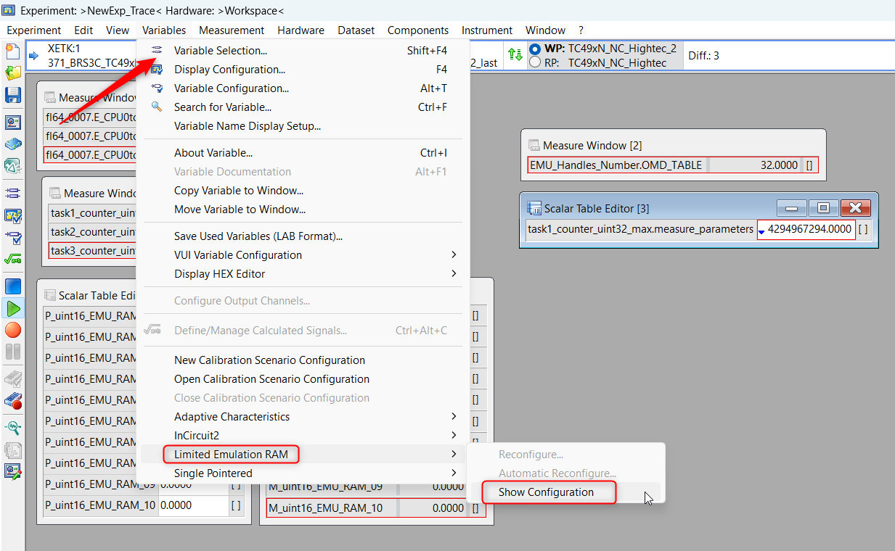
Then you see the type, number of handles and which data segment with size is mapped to which RAM location.

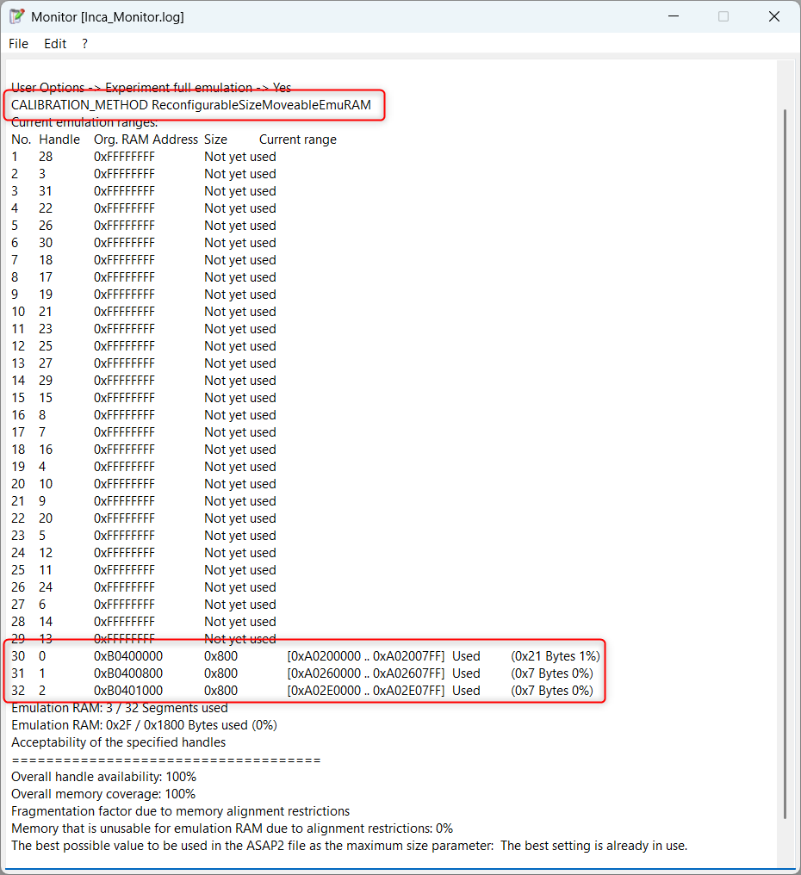
In parallel you can check the same in XCT with uploading the configuration and opening the hex editor. Now navigate to the page switch mailbox address with type variables.
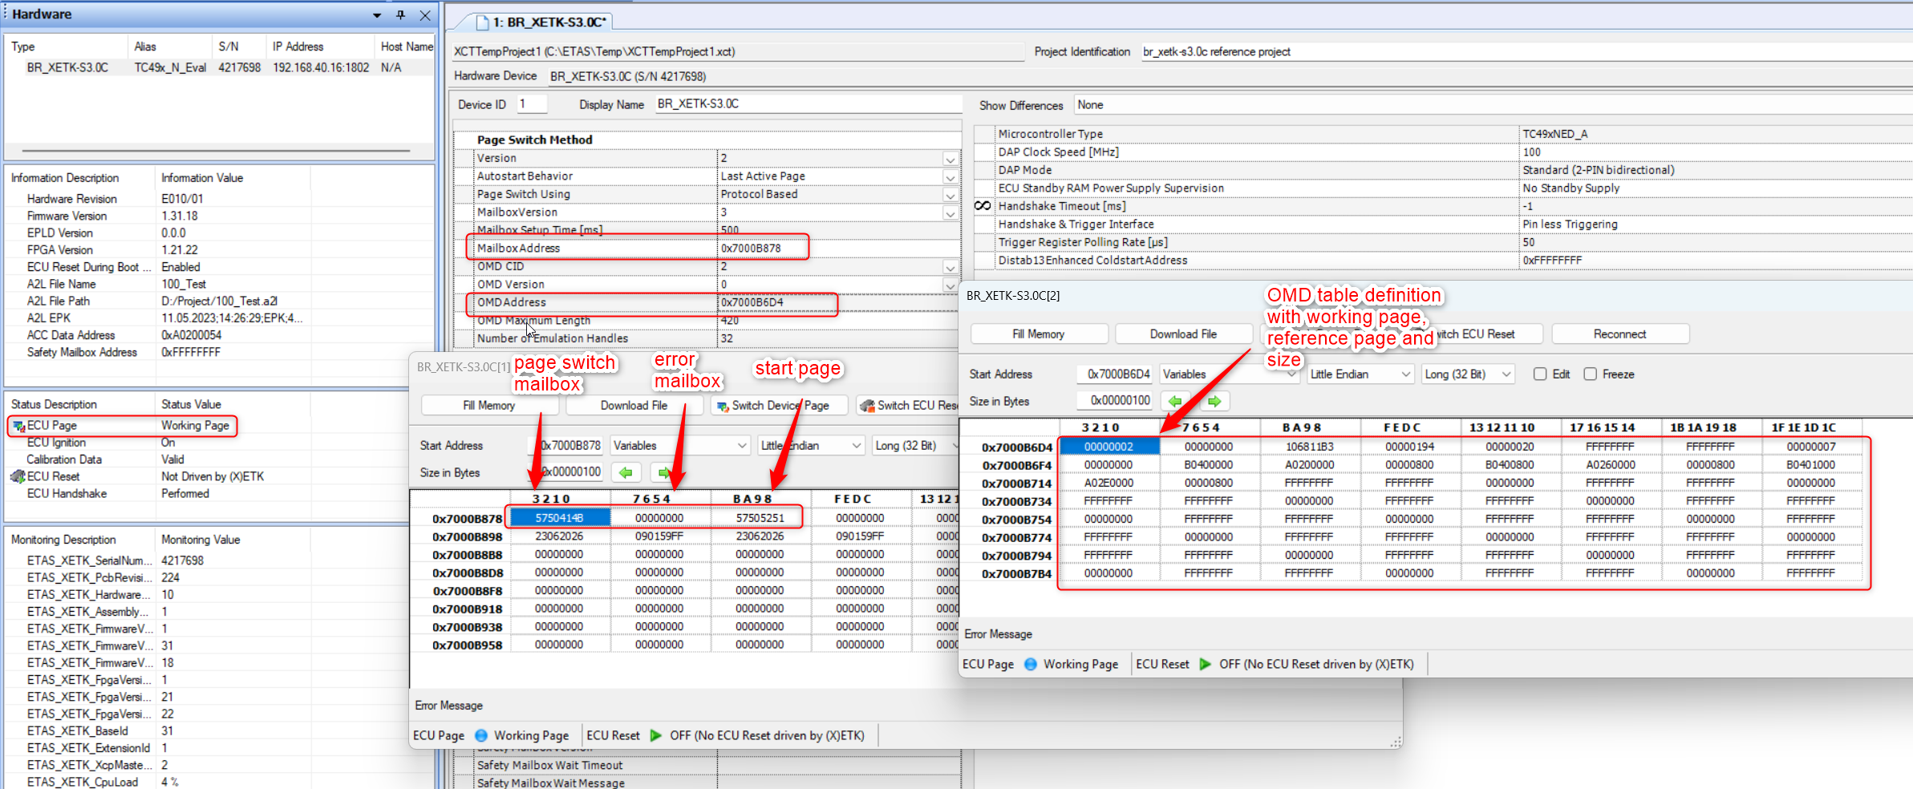

If something is wrong or not working then access to register is not given, trusted functions / HSM is active or some flash is not initialized etc. Best is to begin here maybe with only one small handle to verify and check this function.

Advanced Code Check (ACC)
The advanced code check feature makes sure that the used code and data in INCA is the same like in the flashed ECU. When this is different it doesn’t allows the user to calibrate to avoid inconsistent data between data in INCA and in the ECU.

Needed Files
At first copy the folder ACC into the folder structure in the folder ETK with following files:
Here a short description of the files :
ETK_CodeCheck.c/.h contains the structure for ACC and cyclic copy process.

Changes in Files for integration
Here is definition what must be adapted to ECU software for integration and what must be linked in linker file. In this case is in the added files nothing to change. Only in the

ETK_CodeCheck.c
Nothing mut be changed in the file..
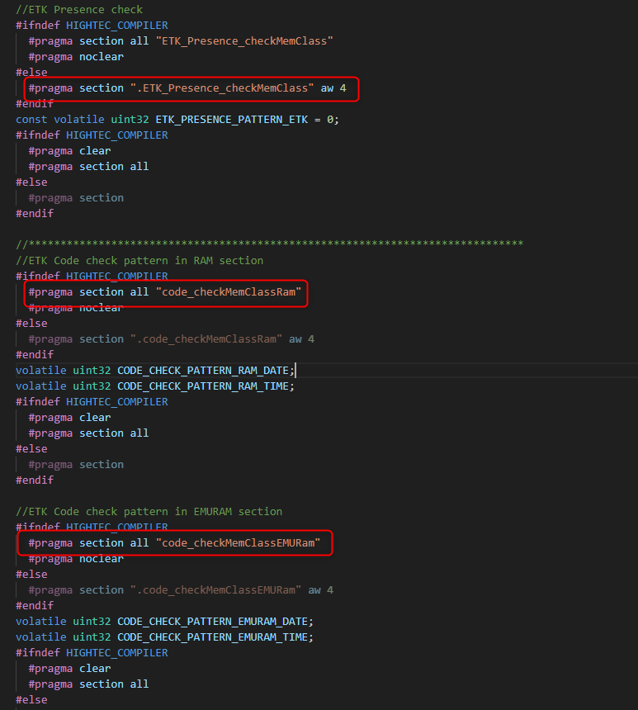
Here you need three parts for ACC. The CodeClass in Flash (defined before in handshake), MemClass in RAM and EMURAM. So now you need to assign to sections.
"code_checkMemClassRam"
"code_checkMemClassEMURam"

You can link it where you want, and it should be 4 byte aligned. As recommendation for uC with EMEM, the class for EMURam must be where you have the page switch method on EMEM and the class for Ram on any SRAM. LMU/DLMU.

group SRAM_CodeCheck_Pattern(ordered, run_addr=0x70000030)
{
select "*.IRAM";
select "*.ERAM";
select "*.code_checkMemClassRam";
….
}
group SRAM_CodeCheck_Pattern(ordered, run_addr=0xB93E0000)
{
select "*.code_checkMemClassEMURam";
select "*.ETK_PageSwitch_MemClass";
select "*.ETK_OMDTable_MemClass";
}

ETK_Integration_Cfg.h
Activate the calibration method by activating define ACC_SUPPORTED. This can be activated independent from all other functions but should be done with calibration.
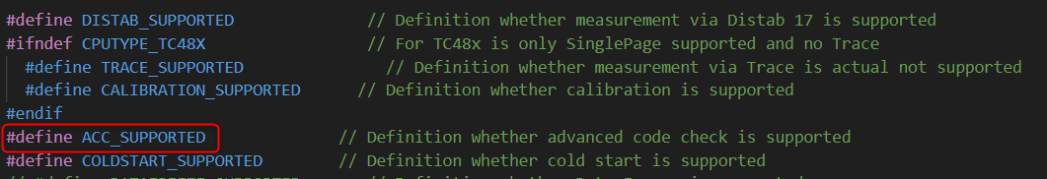

Call of function
The ACC process will be called on two different section.
The initialization of ACC must be called directly before handshake and will be processed with initRAMCheckPattern();.
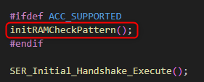
The cyclic called should be done in the same runnable / raster like the page switch method each 10ms and is called with CopyCodeCheckPattern_cyclic(0);.
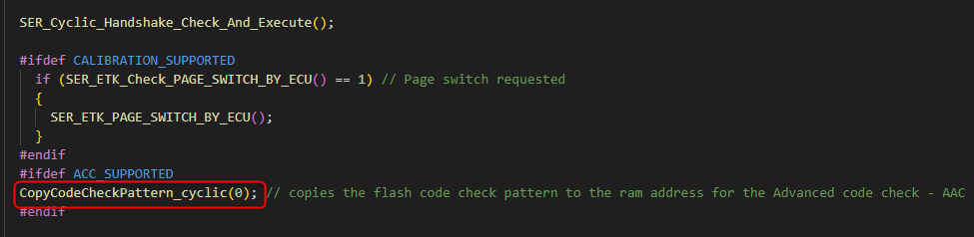
For example, you have three runnable’s with 1ms, 10ms and 100ms you set the call in 10ms following:
FUNC(void, Xetk_CODE) Xetk_CyclicEvent10ms()
{
Distab17_Process(2);
if (SER_ETK_Check_PAGE_SWITCH_BY_ECU() == 1) // Page switch requested
{
SER_ETK_PAGE_SWITCH_BY_ECU();
}
CopyCodeCheckPattern_cyclic(0);
dataCacheInvalidate();
}…

A2L configuration in XCT Tool
When now the code is compiled and flashed, the ETK must be configured that advanced code check is supported and activated. Important is, that the pattern in the code section is in a DATA FLASH memory segment and the RAM and EMURAM MemClass are located in a RAM VARIABLES segment.
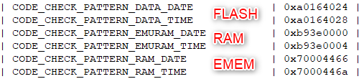
Now load the before created A2L file in XCT tool, open in parallel the .map file and search for the addresses for the CODE_CHECK_PATTERN.
Now enter this on layer Hardware Settings in the correct lines and
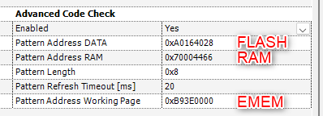
In the lines Pattern Length is the length of pattern defined. Typically is used 8 Byte with 0x8 and for refresh Timeout the 20ms.

Verify in XCT Tool and use in INCA
After import A2L in INCA, reconfigure and initialize in the hardware configuration you will see no change to before because all is working fine. Only when a mismatch in one of the addresses or patterns occur, then a popup window will be opened with the information, what is the reason. When this happens, the user cannot change values and calibrate. When user wants to calibrate, he must flash.
Issue with wrong pattern address :
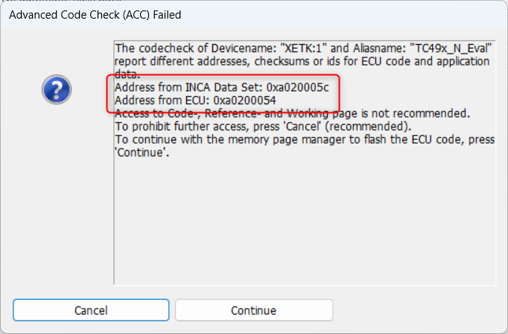

Issue with wrong or missing pattern :
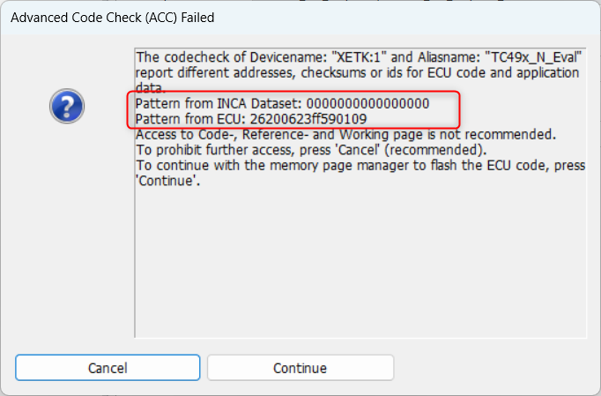
After that information no checksum will be calculated and calibration is forbidden.
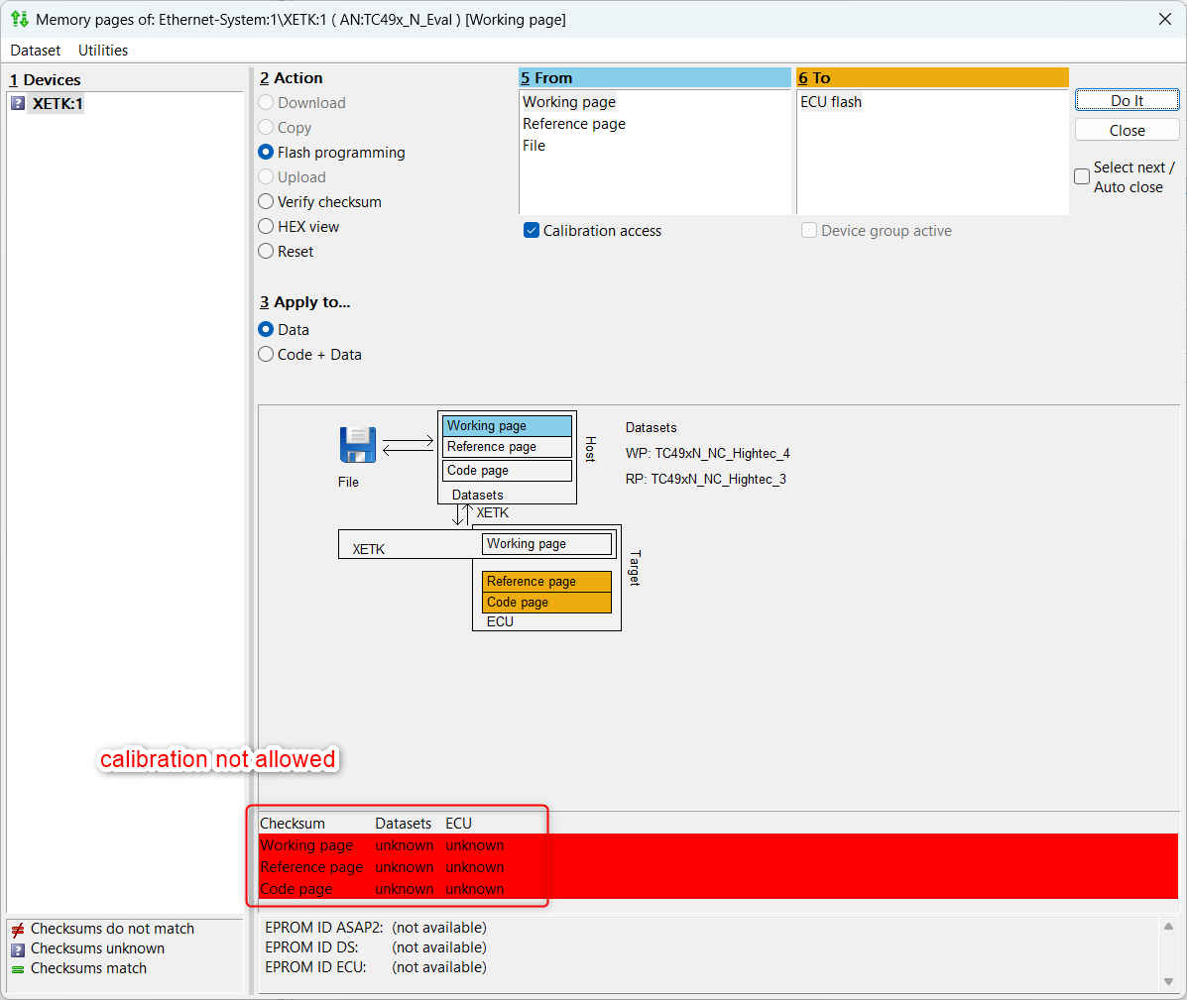

Coldstart measurement
The coldstart measurement feature makes possible for the user to setup the measurement configuration without ignition of ECU and to halt the ECU in handshake till the ignition is on. This allows the customer to make a coldstart measurement. Needed Files
At first copy the folder CS into the folder structure in the folder ETK with following files:
Here a short description of the files :
ETK_SER_Coldstart.c/.h contains the structure for coldstart and process with patterns during the handshake.

Changes in Files for integration
Here is definition what must be adapted to ECU software for integration and what must be linked in linker file.

ETK_SER_Coldstart.c
#include "../../a_std_type.h" should be change to the file for standard types. Typically is used the name Platform_Types.h.
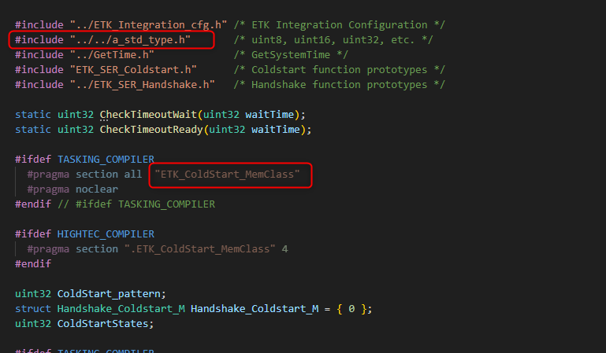
" ETK_ColdStart_MemClass"
You can link it where you want, and it should be 4 byte aligned. As recommendation put the Coldstart class to the Ram on first core CPU0.

group SRAM_CodeCheck_Pattern(ordered, run_addr=0x70000030)
{
select "*.IRAM";
select "*.ERAM";
select "*.ETK_ColdStart_MemClass";
select "*.code_checkMemClassRam";
….
}

ETK_Integration_Cfg.h
Activate the coldstart method by activating define COLDSTART_SUPPORTED. This can be activated independently from all other functions but should be done with calibration.
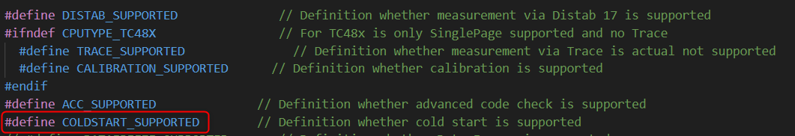

Call of function
The coldstart process will be executed during initial handshake process. For that is no separate call necessary.

A2L configuration in XCT Tool
When now the code is compiled and flashed, the ETK must be configured that coldstart handshake is supported and activated. Important is, that the Coldstart Class is located in a RAM VARIABLES segment.
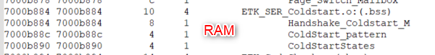
Now load the before created A2L file in XCT tool, open in parallel the .map file and search for the address of Coldstart_pattern. In this case its 0x7000B88C.
Now enter this on layer Hardware Settings in the correct lines and
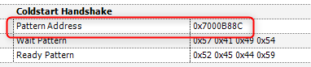
In the lines Wait and Ready Pattern there should be the same patterns like in the code used. Default values are 0x57 0x41 0x49 0x54 for wait pattern and 0x52 0x45 0x44 0x59 for ready pattern.
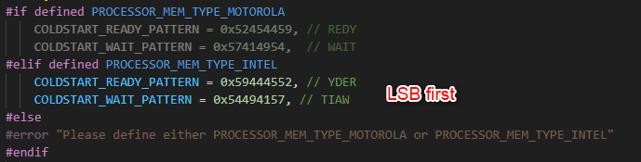

Verify in XCT Tool and use in INCA
After import A2L in INCA, reconfigure and initialize in the hardware configuration you will see, that you are able to initialize when ignition is off and start measurement. You will see that INCA displays that ECU is off.
With TC4xx you have no reset resistant memory, that means coldstart measurement cannot be done starting from working page, because INCA does then automatically reinitializing and this takes time. Here as hint is to deactivate before the ECU access in INCA over MPM and then do the coldstart measurement.
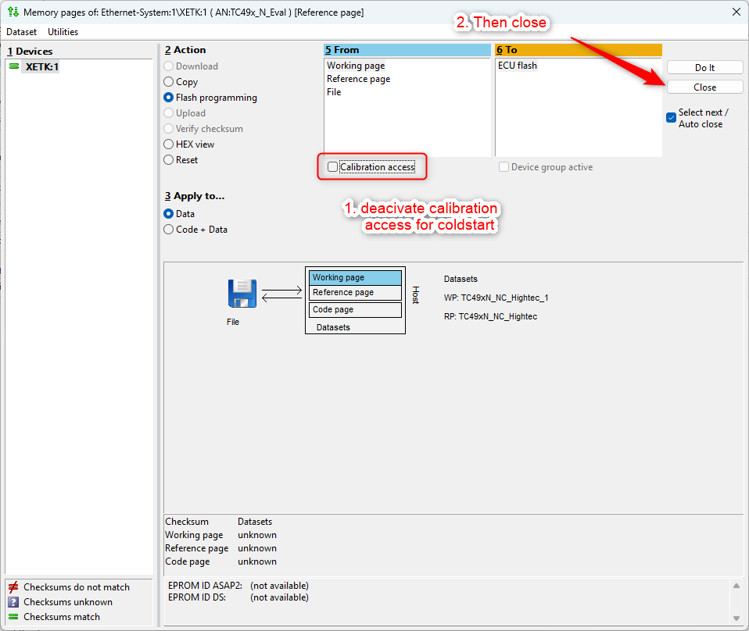
You will see No access and no values
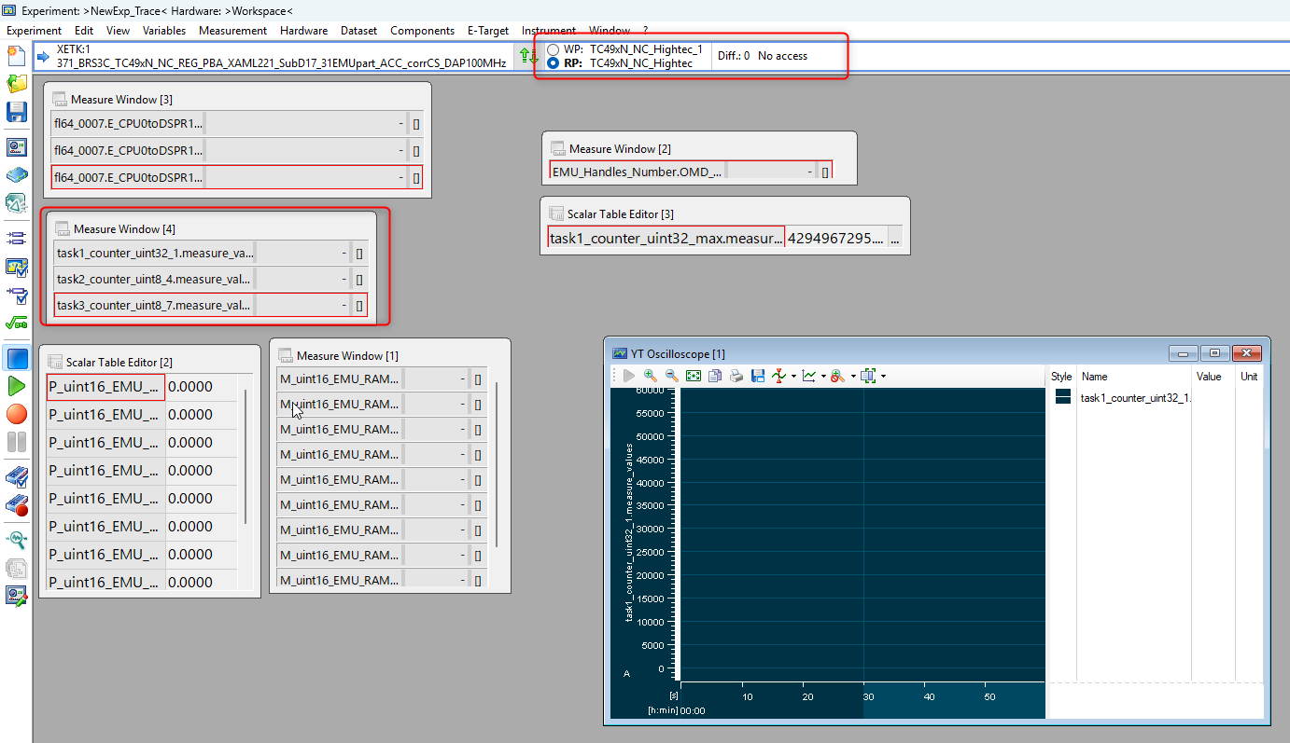

In the moment, when ignition is on immediately you can see values in INCA.
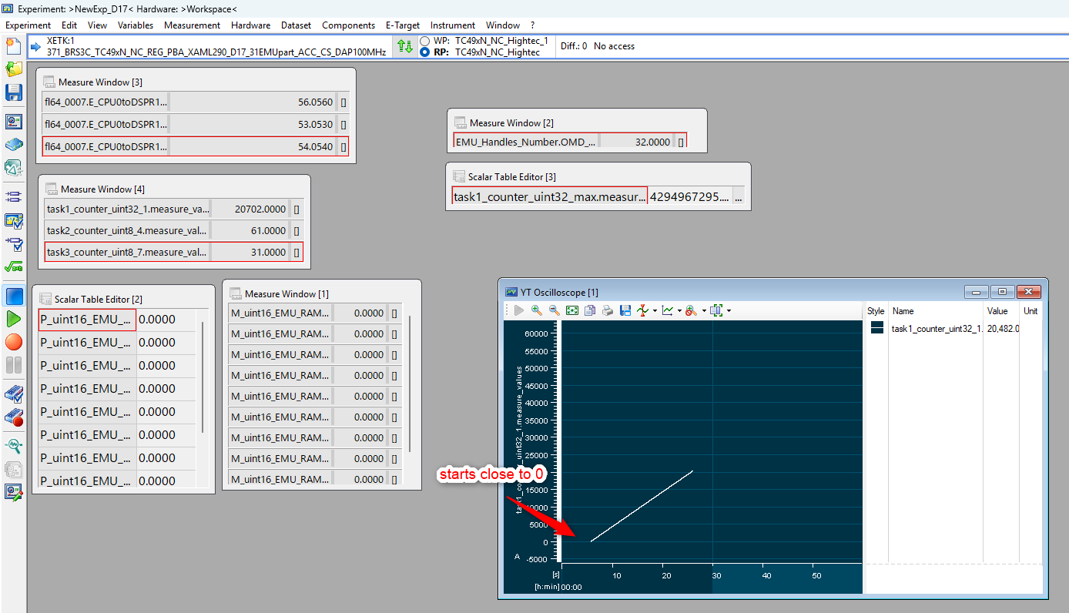

Early measurement can be verified in MDA8 with checking first values. Normally values are incremented before the Distab routine will be called what the reason is that in generally the first value will be recorded with 1.

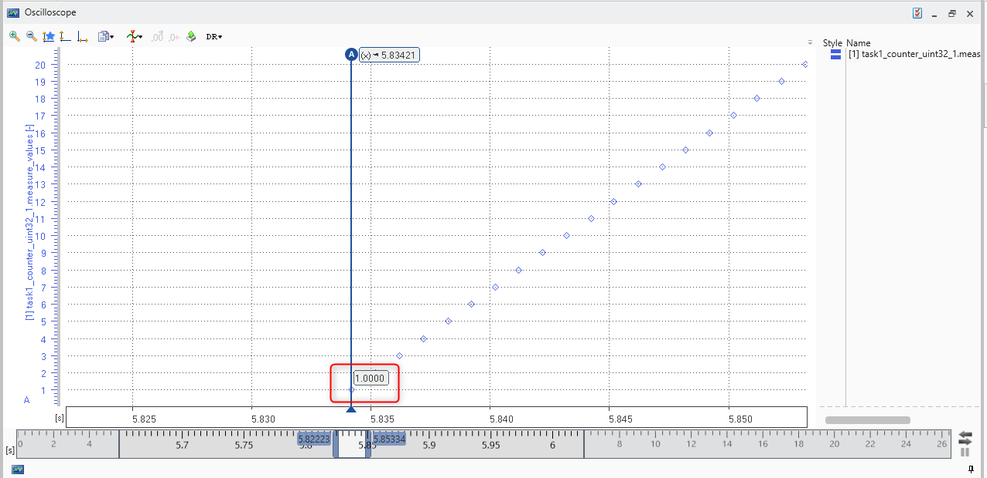

Contact Information

Technical Support

For details of your local sales office as well as your local technical support team and product hotlines, take a look at the website: www.etas.com/hotlines

ETAS Headquarters
ETAS GmbH
Borsigstraße 24 | Phone: | +49 711 3423-0
70469 Stuttgart | Fax: | +49 711 3423-2106
Germany | Internet: | www.etas.com

Figures
Tables

Index

E
ETAS, 6

Revision History

